TestRail – Day 1: Basics, Account Setup, UI & Project Creation
Date: 24-Jan-2026
Learning Objective
• To understand TestRail fundamentals
• To create a TestRail account
• To explore the TestRail user interface and navigation
• To create a TestRail project

1. TestRail Overview
Definition:
• TestRail is a test management tool used to plan, manage, execute, and track software testing activities efficiently.
Learning Points:
• Centralized test case management
• Supports both manual and automated testing
• Integrates with defect tracking and CI/CD tools
📸 Screenshot to add:
• TestRail official homepage

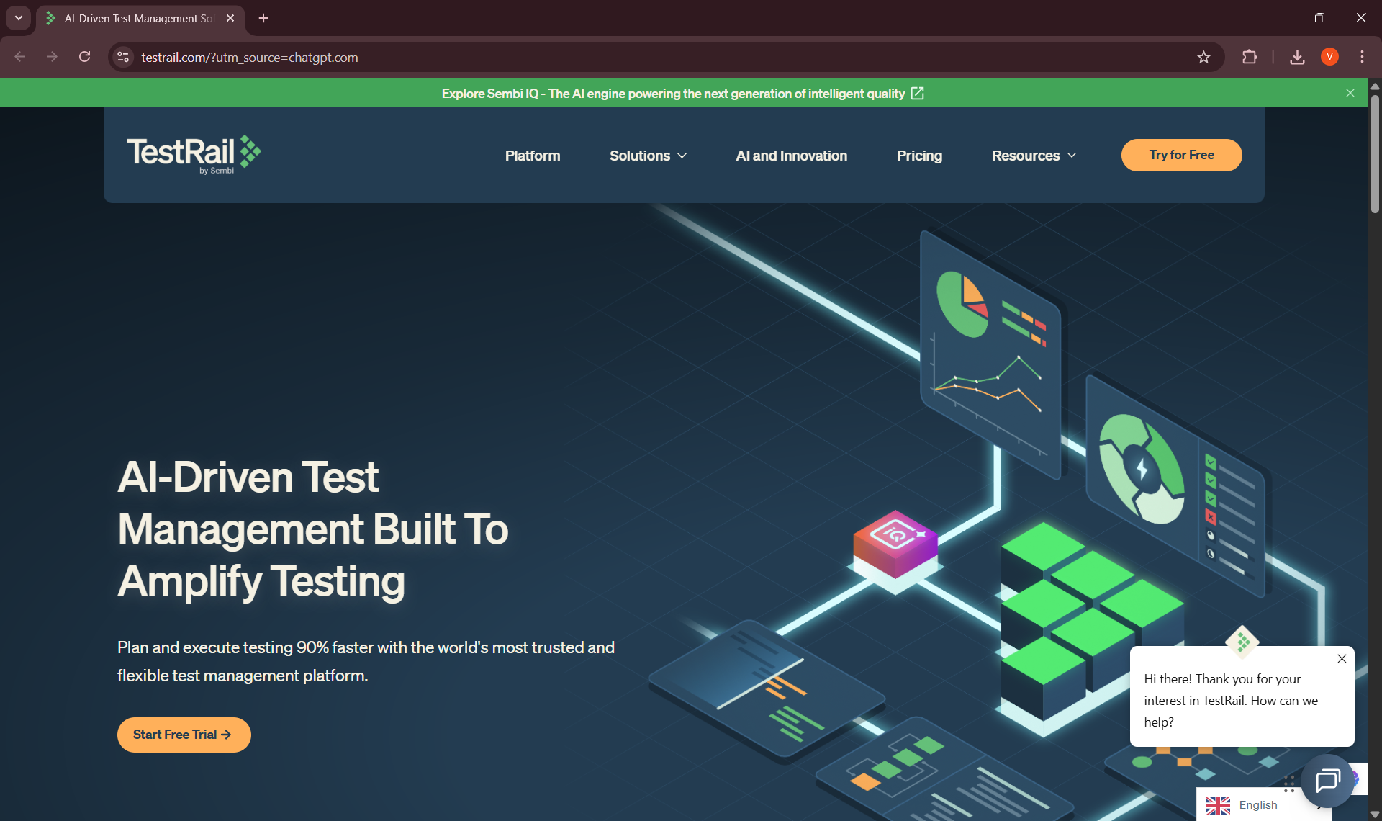
2. TestRail Account Creation
Website Link:
• https://www.testrail.com
Definition:
• A TestRail account provides access to cloud-based test management features for creating and managing testing artifacts.
Steps Followed:
• Visited the official TestRail website
• Clicked on Start Free Trial / Try TestRail
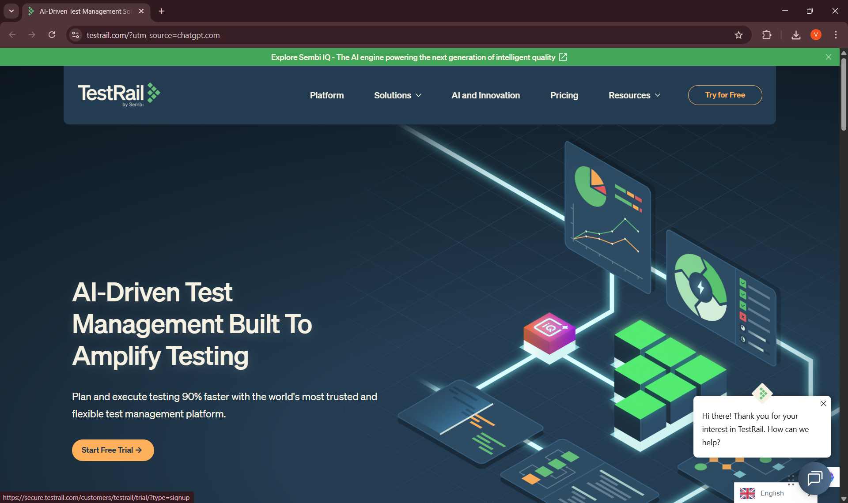
• Entered user details (name, email, password)
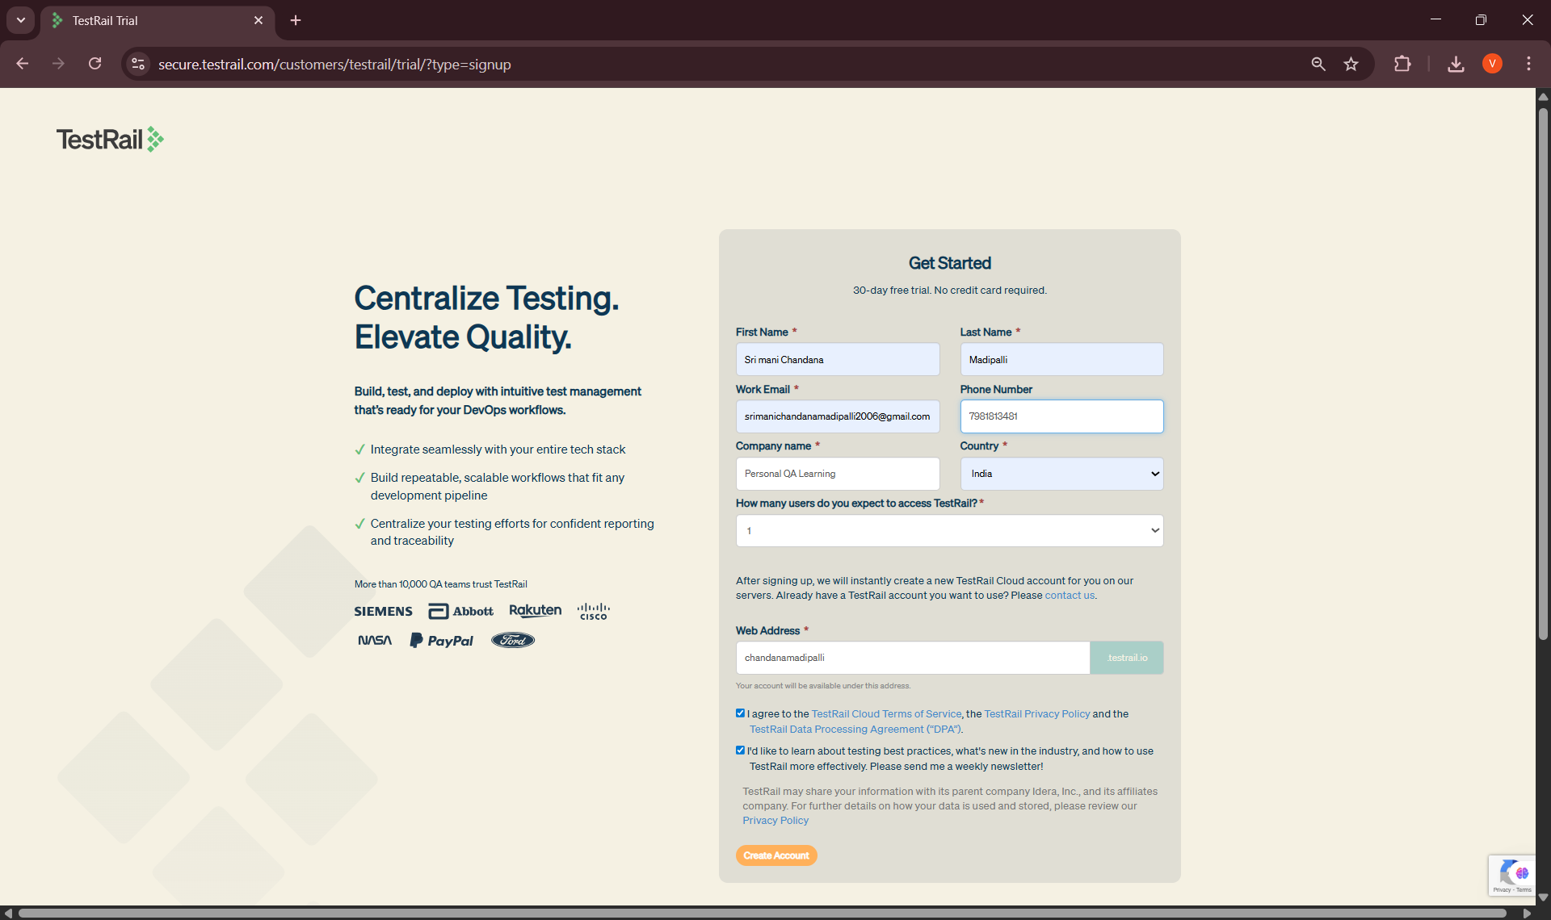
• Created a TestRail cloud instance (sub-domain)
• Verified account through email confirmation
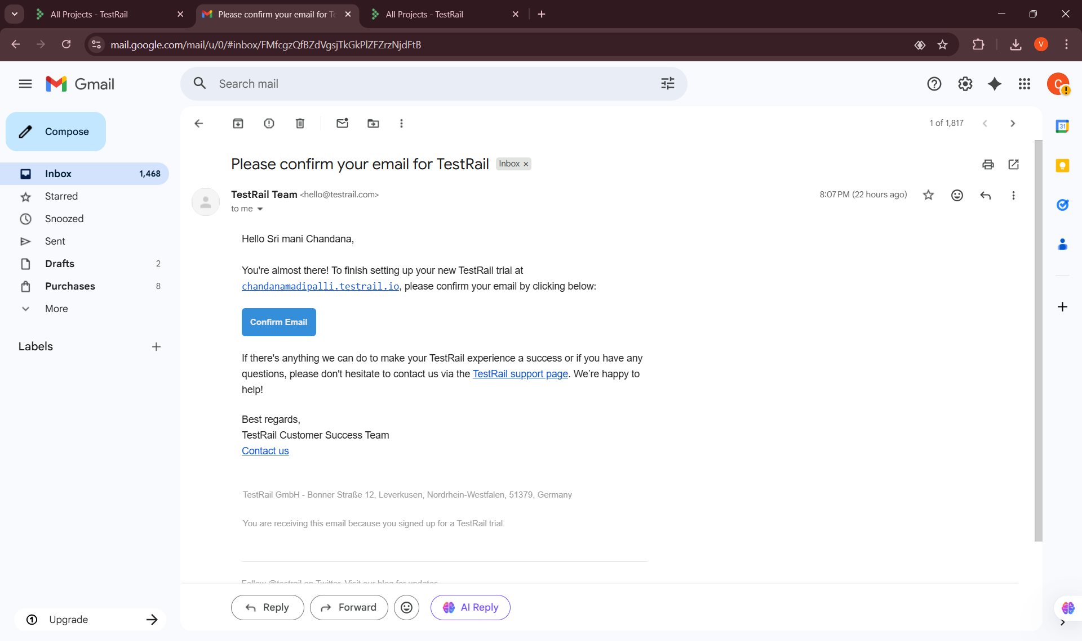
• Logged into TestRail dashboard successfully
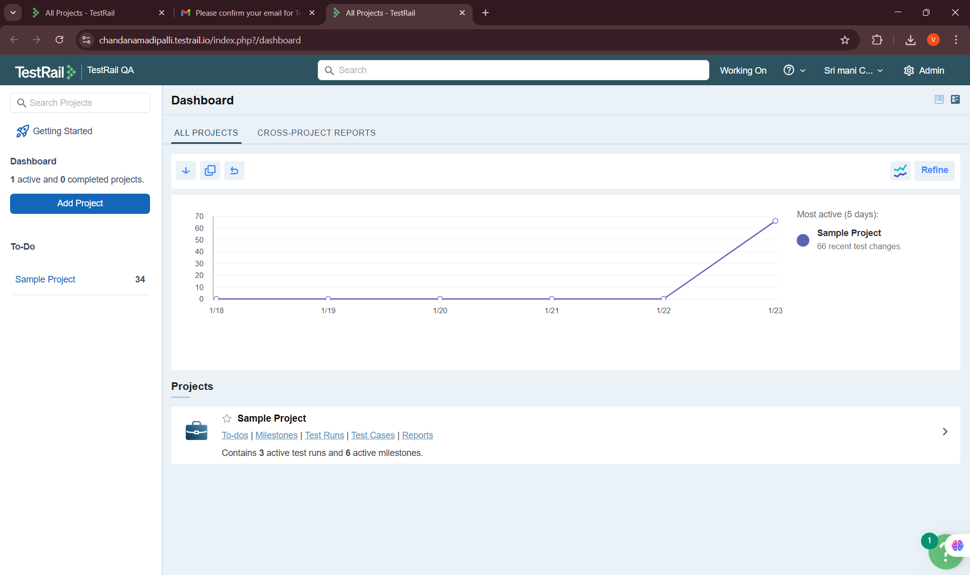
3. TestRail User Interface (UI)
Definition:
• The TestRail UI provides structured navigation for managing projects, test cases, test runs, and reports.
Learning Points:
• Top navigation bar for quick access
• Dashboard showing project overview
• Clear separation of test management modules
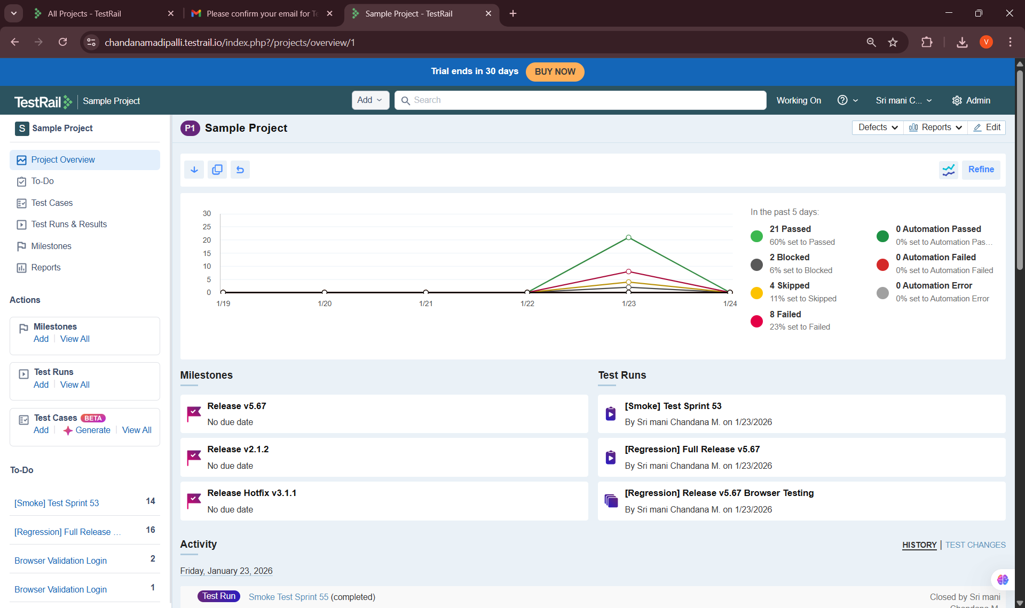
4. Navigation in TestRail
Definition:
• Navigation in TestRail allows users to efficiently move across projects, test cases, runs, and reports.
Learning Points:
• Navigated through dashboard and project sections
• Identified modules such as Test Cases, Test Runs, and Reports
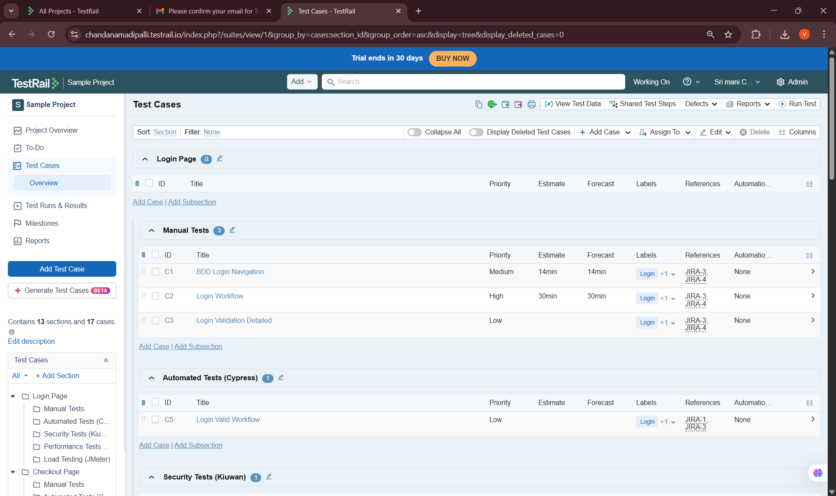

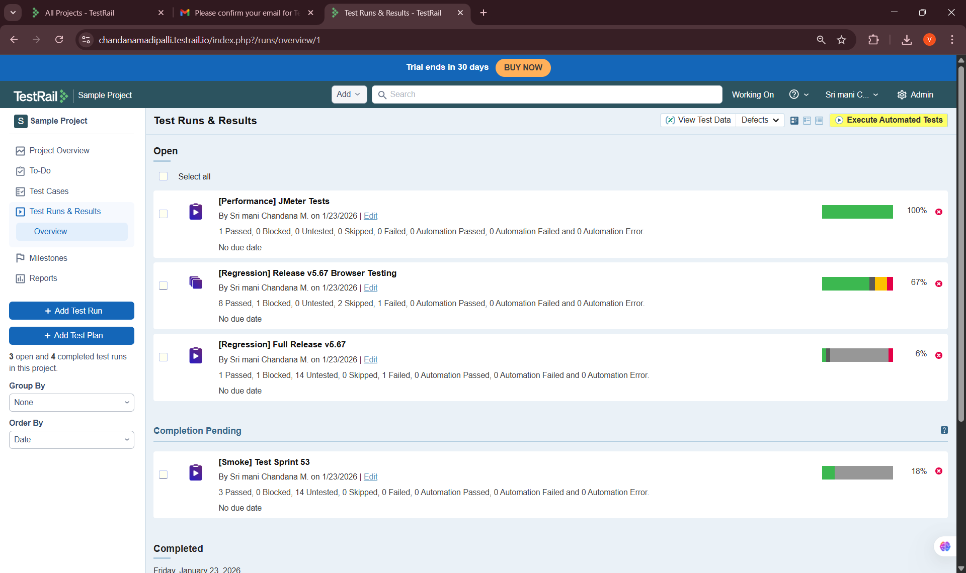
• Understood global vs project-level navigation
5. TestRail Project Creation
Definition:
• A TestRail project is a workspace where all test cases, test runs, and reports for an application are managed.
Learning Points:
• Created a new TestRail project
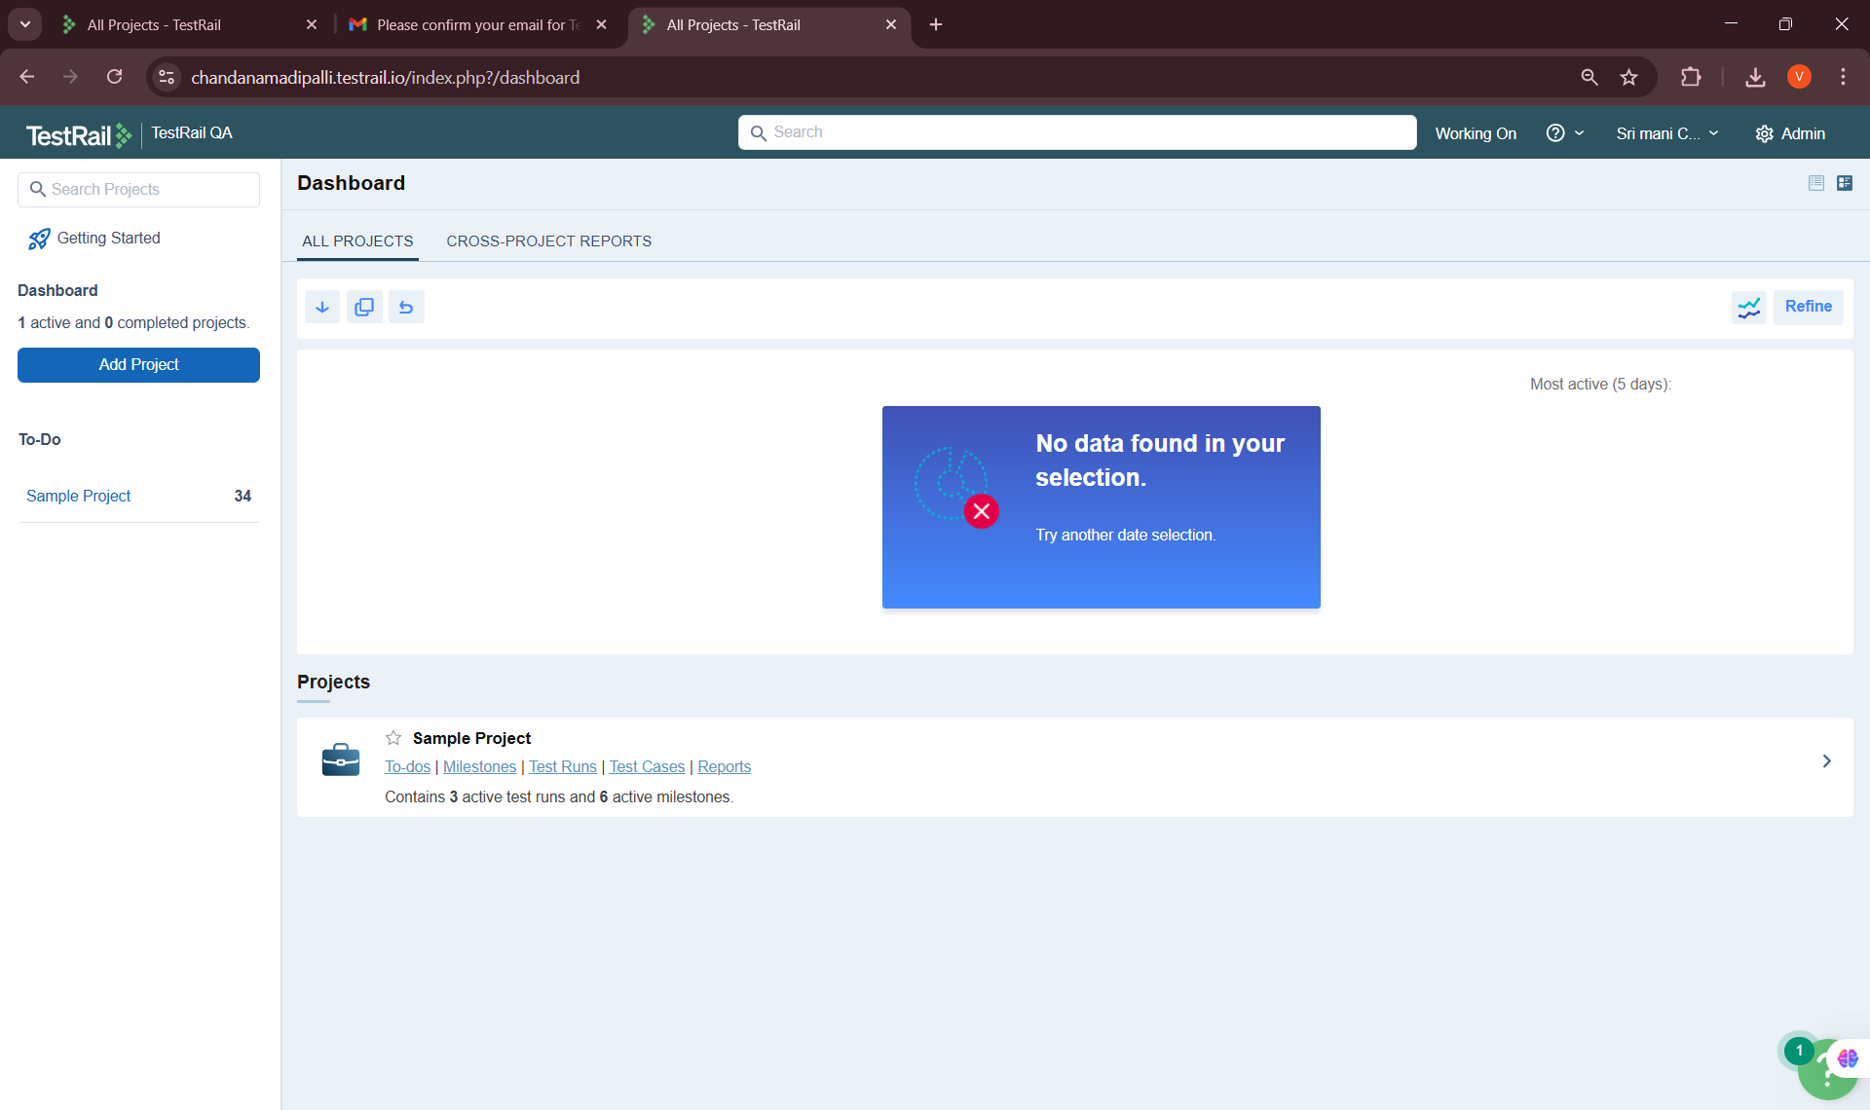
• Selected appropriate project configuration
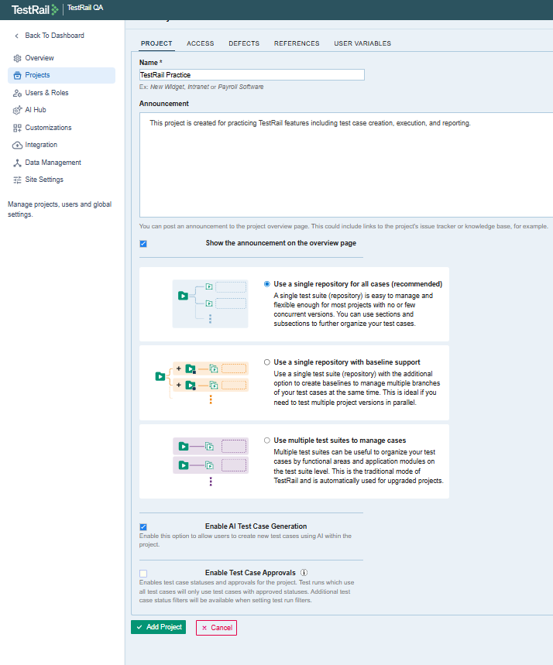
• Verified project dashboard and settings
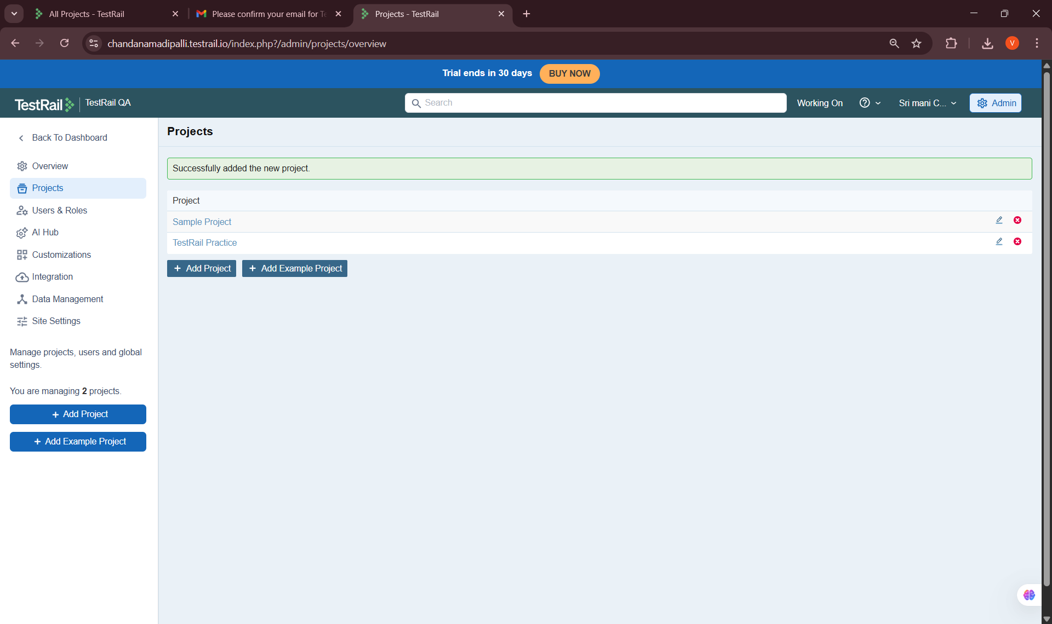
Key Learnings & Outcomes
• Understood TestRail fundamentals and use cases
• Successfully created and verified a TestRail account
• Gained familiarity with TestRail UI and navigation
• Created a TestRail project successfully
• Built a strong foundation for advanced TestRail features

